Aleksas Murauskas

260718389

ECSE 427: Operating Systems

Assignment 2: Readers Writers

Question 1: Write the program implementing the above pseudo-code for the readers-writers problem. Run the program. Reader repeat count is set at 60 and writer repeat count is 30. Measure the waiting times of the readers and writers. Find the minimum, maximum, and average of the waiting times. Does your implementation have a starvation problem? Briefly explain your answer. That is, explain why you concluded that there is starvation or no starvation

Answer 1: The implementation of A2Q1.c does have a starvation problem as shown below that the writer threads have been starved. The maximum writing time is roughly 100 times larger than the maximum reading time. And the average writing time is roughly 2200 times longer than the average reading time. This is caused by the way the semaphores have been set up, which allows the readers to starve the writers. The writers are denied the ability to run due to readers hogging all the resources.

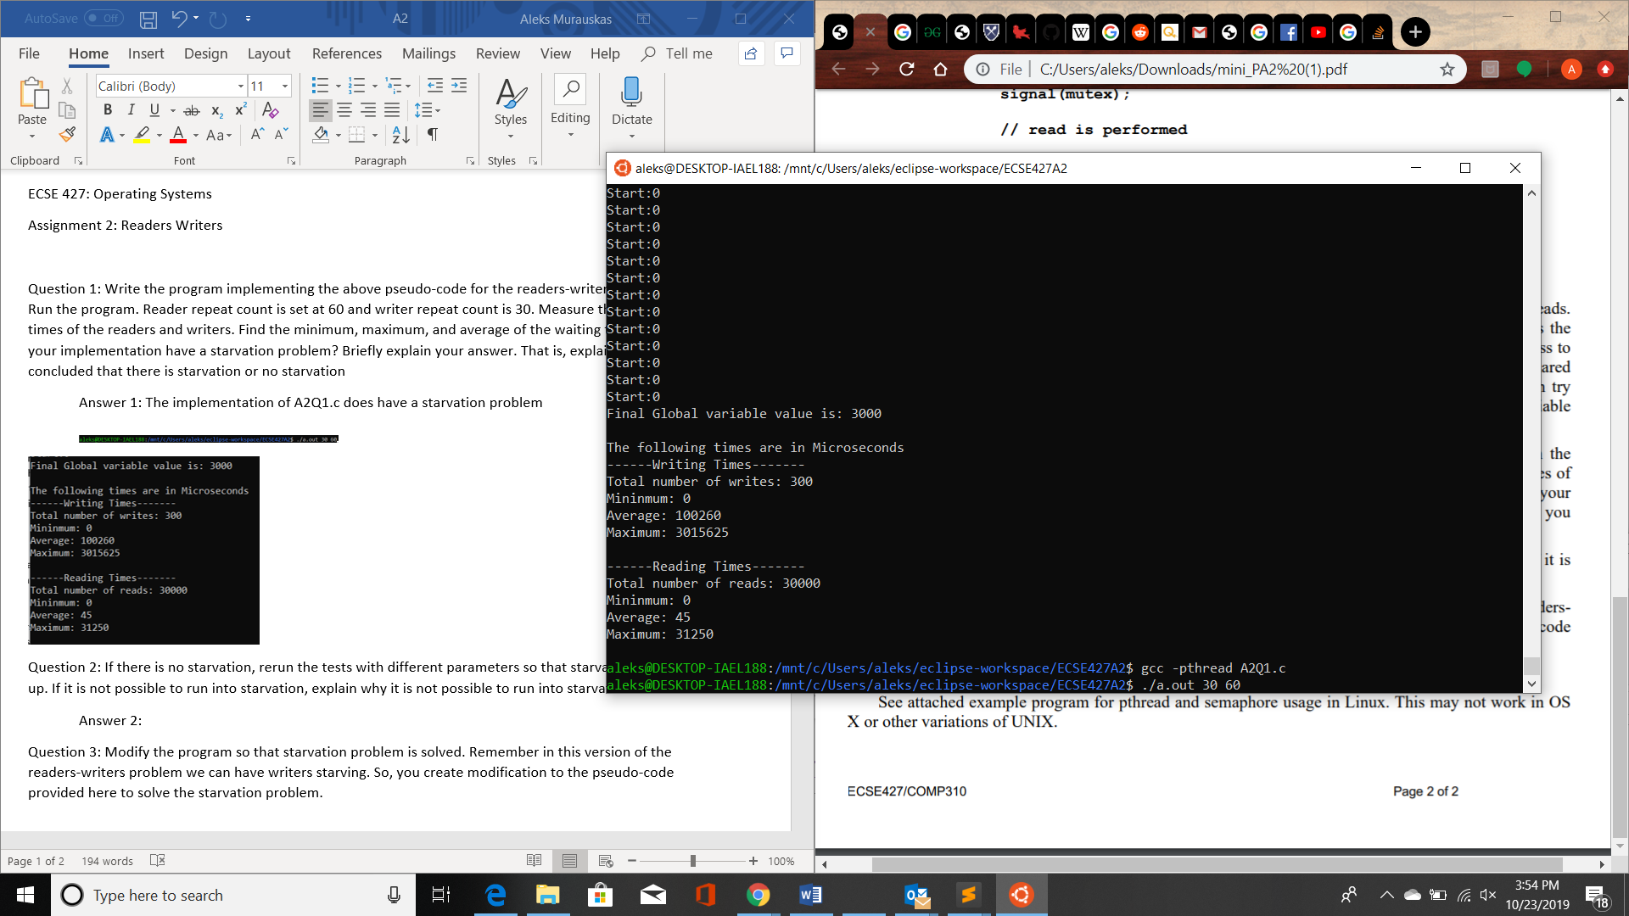

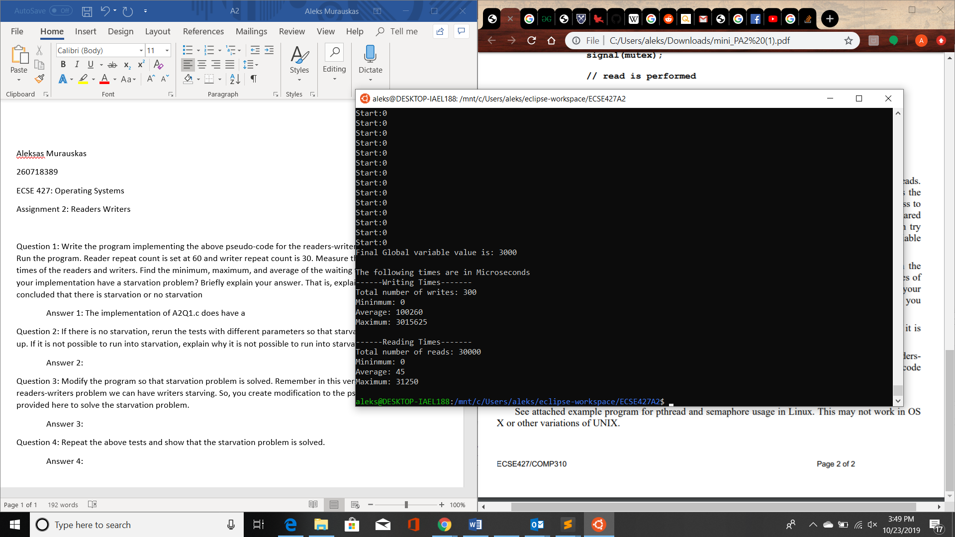 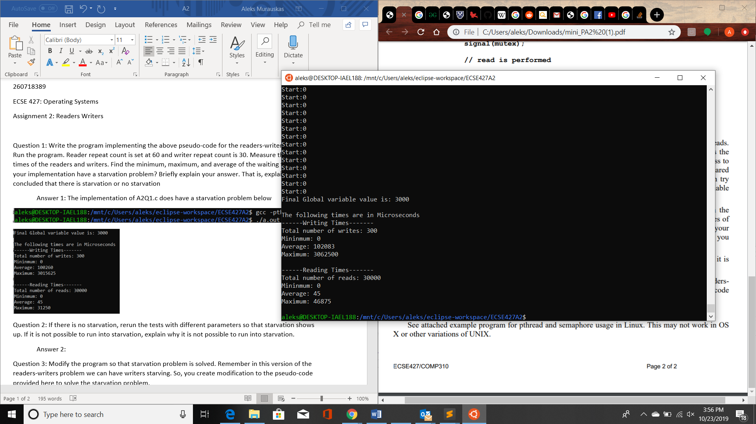 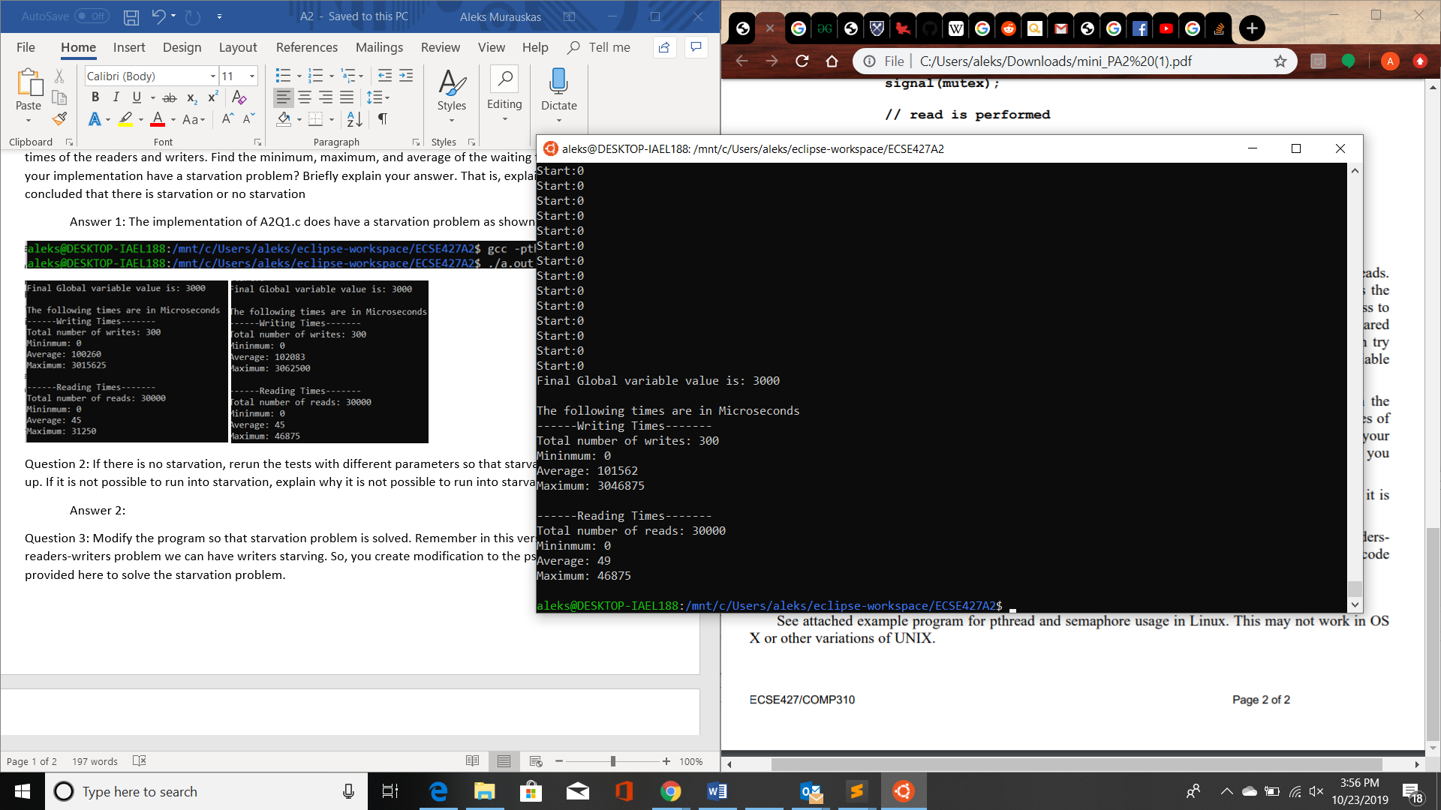

Question 2: If there is no starvation, rerun the tests with different parameters so that starvation shows up. If it is not possible to run into starvation, explain why it is not possible to run into starvation.

Answer 2: Here are some more example of starvation with differing parameters

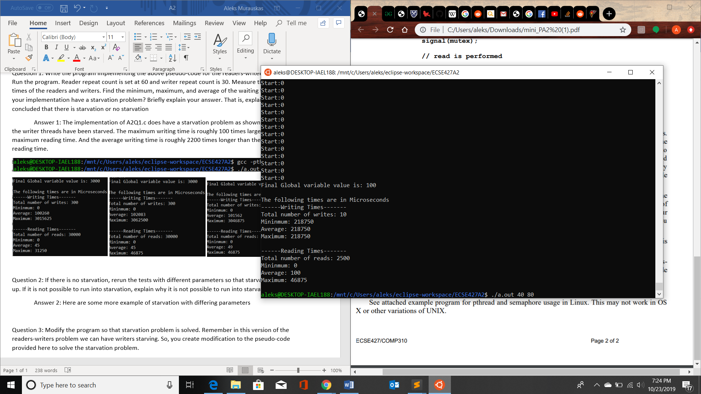 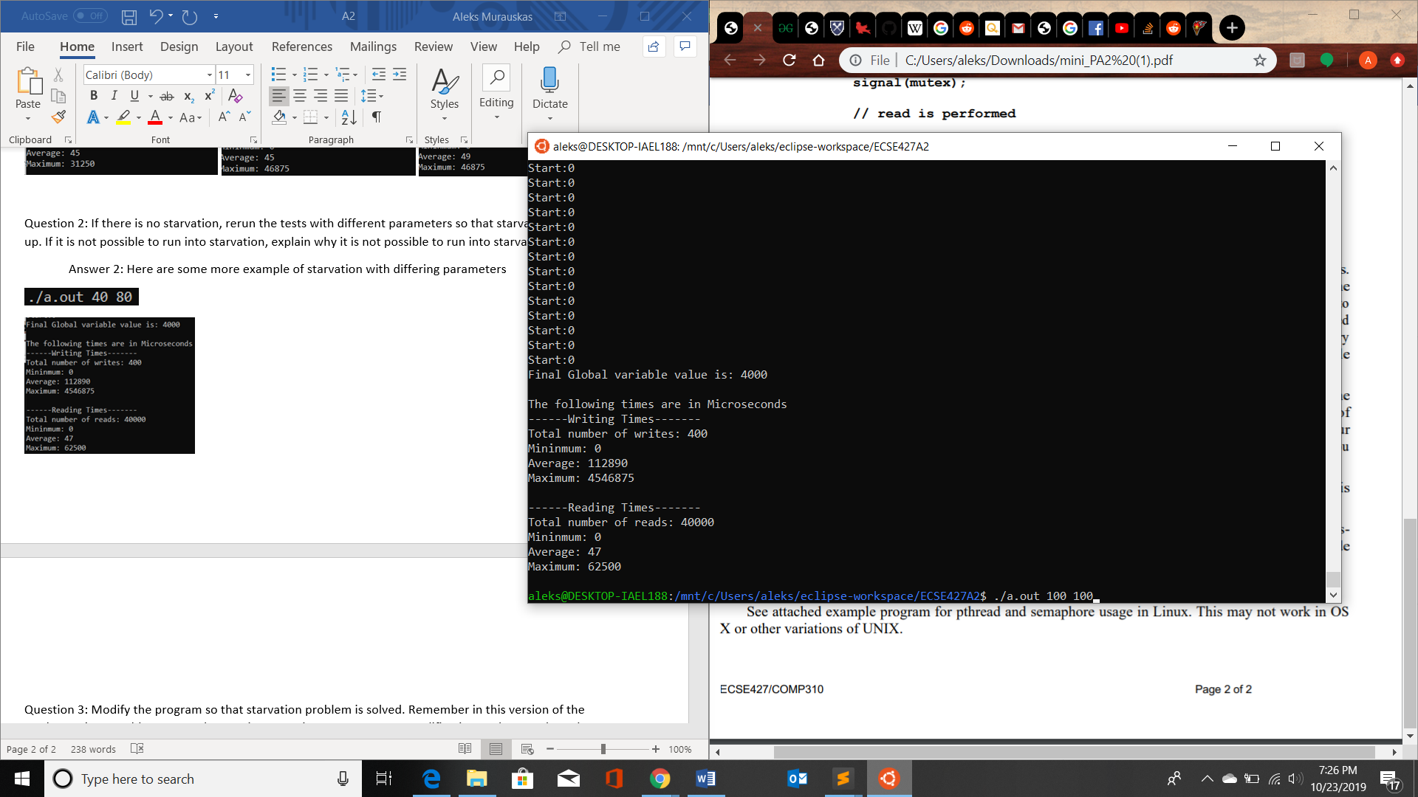 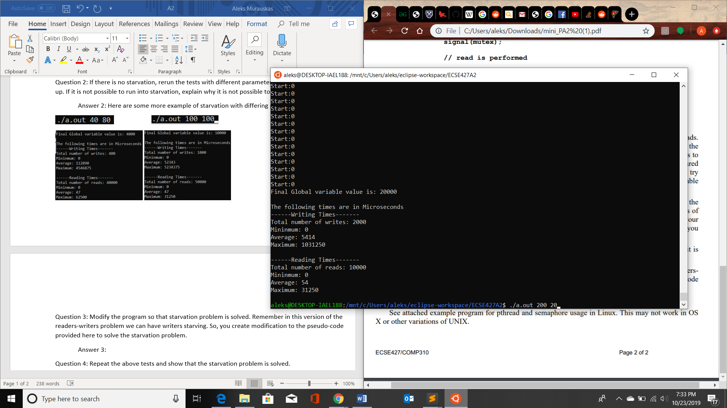

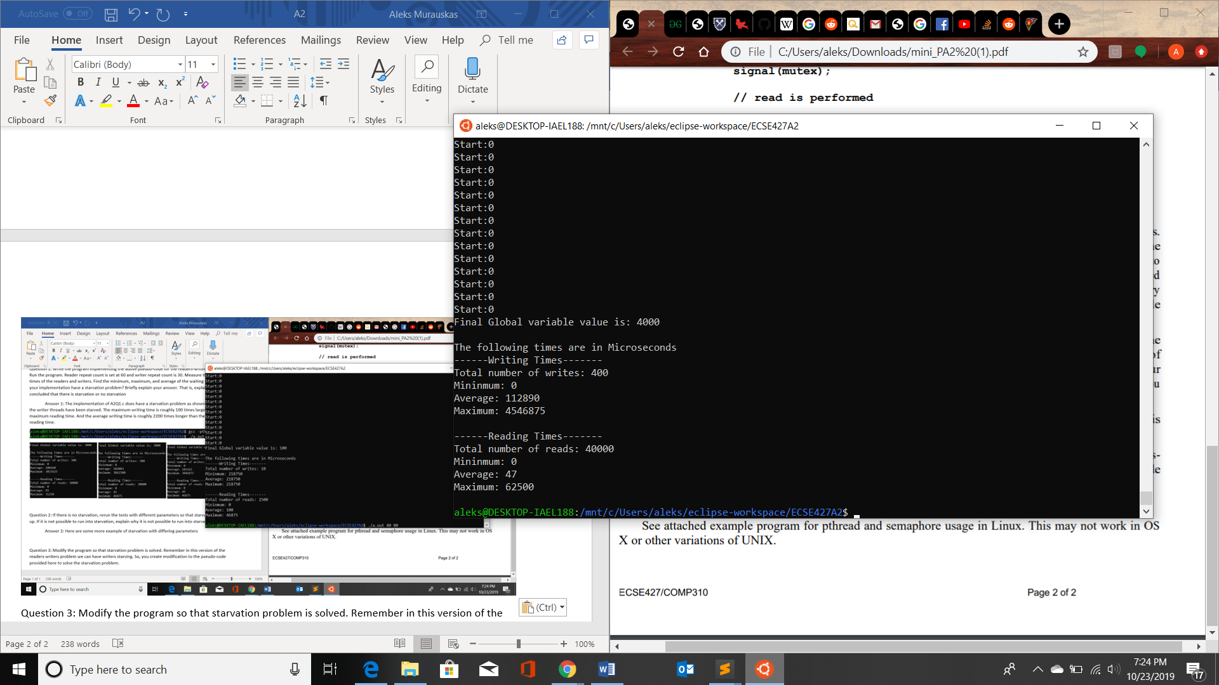 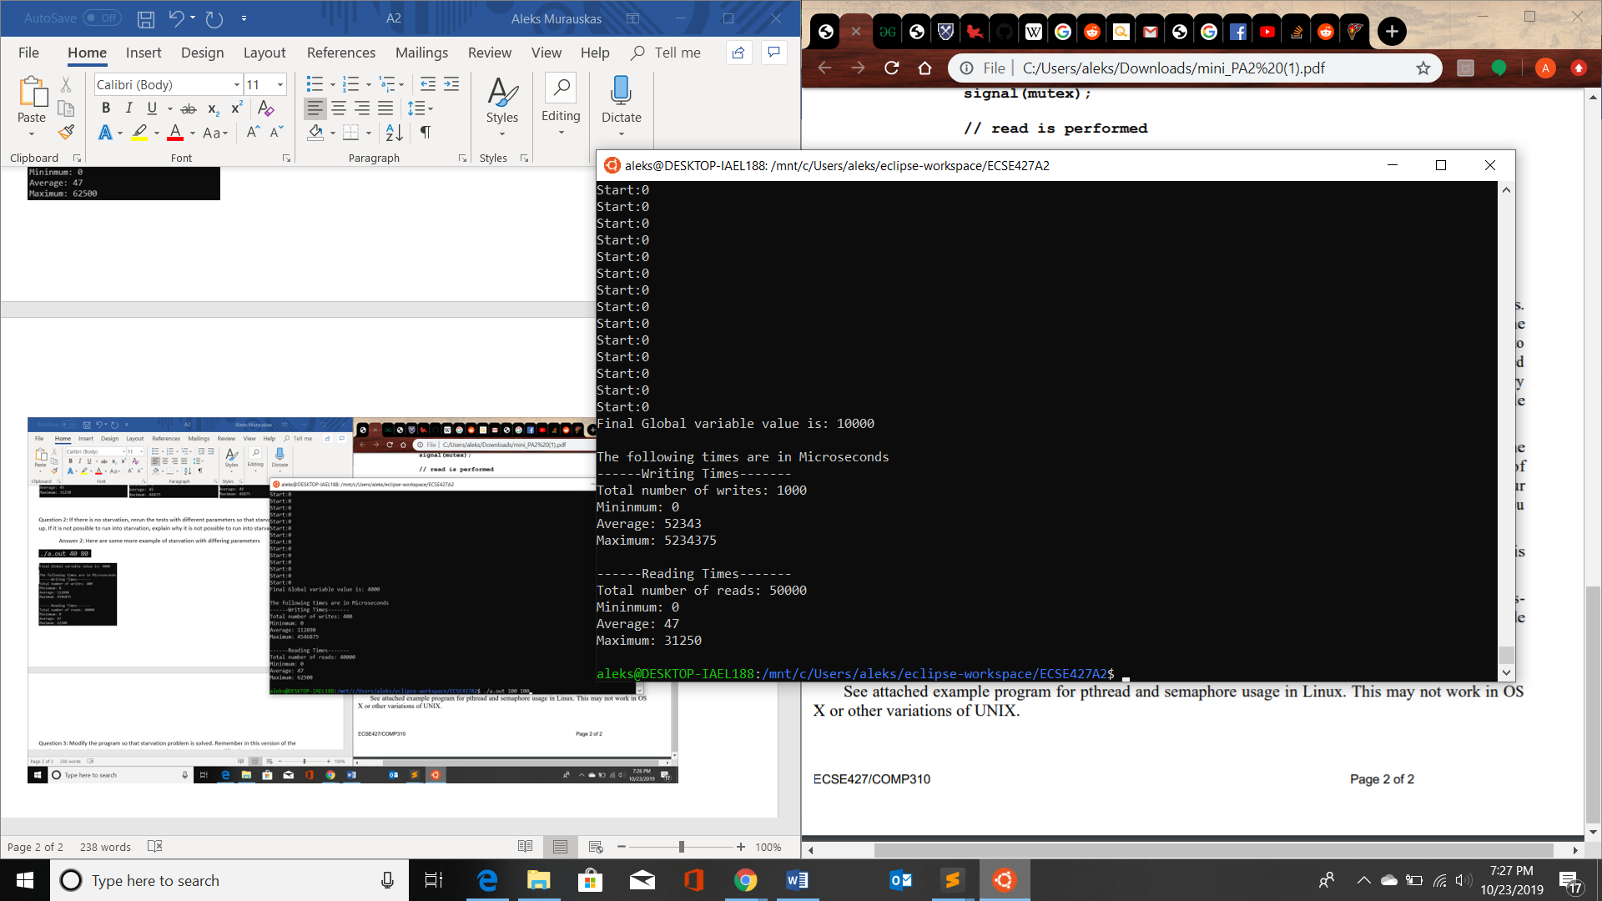 

Question 3: Modify the program so that starvation problem is solved. Remember in this version of the readers-writers problem we can have writers starving. So, you create modification to the pseudo-code provided here to solve the starvation problem.

Answer 3: A2Q3.c contains updated code that does not have starvation problem we have seen in A2Q1.c. As shown in the tests seen in Answer 4, the difference in average and maximum read and write times were much more even, all values are within the same power of 10 or slightly above. The reduction in wait times for write shows they are no longer starved as they were in A2Q1.c.

Question 4: Repeat the above tests and show that the starvation problem is solved.

Answer 4: The following is a repeat of all the tests shown earlier in answers 1 and 2.

